**Ice task 4**

--QUESTION 1

--DATABASE

CREATE DATABASE DVD_RENTALS;

--TABLES

CREATE TABLE DVDS(DVD_CODE VARCHAR(5) NOT NULL PRIMARY KEY, DVD_TITLE VARCHAR(40) NOT NULL,

DIRECTOR VARCHAR(40) NOT NULL, RELEASE_DATE SMALLDATETIME NOT NULL, RUNNING_TIME SMALLINT NOT NULL);

CREATE TABLE STORES(STORE_CODE VARCHAR(5) NOT NULL PRIMARY KEY, STORE_NAME VARCHAR(20) NOT NULL, ADDRESS VARCHAR(50) NOT NULL,

CITY VARCHAR(20) NOT NULL);

CREATE TABLE AVAILABILITY(DVD_CODE VARCHAR(5) NOT NULL, STORE_CODE VARCHAR(5) NOT NULL, AVAILABLE_STOCK SMALLINT NOT NULL

PRIMARY KEY(DVD_CODE, STORE_CODE),

FOREIGN KEY (DVD_CODE) REFERENCES DVDS(DVD_CODE),

FOREIGN KEY (STORE_CODE) REFERENCES STORES(STORE_CODE));

--INSERT INTO

INSERT INTO DVDS

VALUES ('D001', 'joker', 'Todd Phillips', '2019-08-15', 122),

('D002', 'Booksmart', 'Olivia Wilde', '2019-03-10', 105),

('D003', 'Gemini MAn', 'Ang Lee', '2019-10-01', 117),

('D004', 'Atlantics', 'Mati Diop', '2019-05-16', 124),

('D005', 'The Farewell', 'Lulu Wang', '2019-01-25', 100);

INSERT INTO STORES

VALUES('ST001', 'DVD Express', '167 Pert Road', 'Johannesburg'),

('ST002', 'DVD Rentals', '5 Second Avenue', 'Port ELizabeth'),

('ST003', 'Movies R Us', '33 Bertha Mkhize Street', 'Durban'),

('ST004', 'Pro Visions DVDs', '27 Bram Fischer Road', 'Durban'),

('ST005', 'Protea DVD Shop', '210 Du Toit Street', 'Pretoria');

INSERT INTO AVAILABILITY

VALUES('D002', 'ST001', 13),

('D002', 'ST004', 9),

('D003', 'ST005', 8),

('D004', 'ST003', 5),

('D004', 'ST001', 9);

--ALTER

ALTER TABLE AVAILABILITY

ADD STOCK_ORDERED SMALLINT;

--UPDATE

UPDATE AVAILABILITY

SET STOCK_ORDERED = 3

WHERE DVD_CODE = 'D004' AND STORE_CODE = 'ST003';

--QUESTION 2

SELECT DVDS.DVD_TITLE, DVDS.DIRECTOR FROM DVDS

LEFT JOIN AVAILABILITY ON DVDS.DVD_CODE = AVAILABILITY.DVD_CODE

WHERE AVAILABILITY.AVAILABLE_STOCK IS NULL;

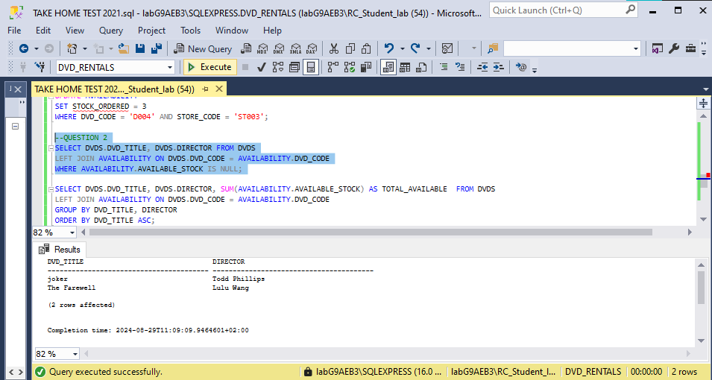

SELECT DVDS.DVD_TITLE, DVDS.DIRECTOR, SUM(AVAILABILITY.AVAILABLE_STOCK) AS TOTAL_AVAILABLE FROM DVDS

LEFT JOIN AVAILABILITY ON DVDS.DVD_CODE = AVAILABILITY.DVD_CODE

GROUP BY DVD_TITLE, DIRECTOR

ORDER BY DVD_TITLE ASC;

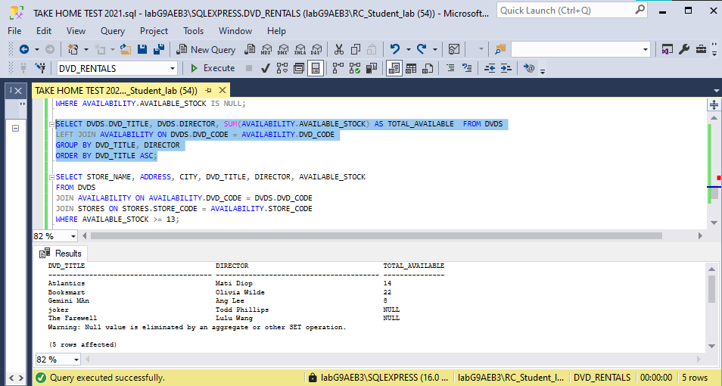

SELECT STORE_NAME, ADDRESS, CITY, DVD_TITLE, DIRECTOR, AVAILABLE_STOCK

FROM DVDS

JOIN AVAILABILITY ON AVAILABILITY.DVD_CODE = DVDS.DVD_CODE

JOIN STORES ON STORES.STORE_CODE = AVAILABILITY.STORE_CODE

WHERE AVAILABLE_STOCK >= 13;

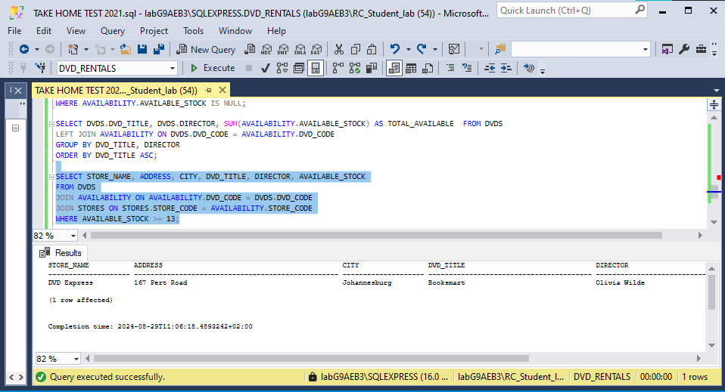

**Reference**

Gido, J. Clements, P.J. Baker, R. 2022. Successful Project Management in South Africa. Second edition. Boston: Congage Learning.